Black Sea Link
RESEARCH FELLOWSHIP Program At the New Europe College, Bucharest
Call for Applications
Academic Year 2012/2013
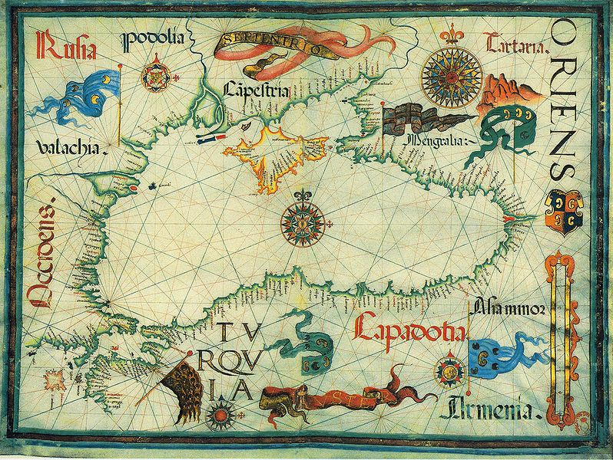
The Black Sea Link program offers research fellowships for young, highly talented scholars in the Humanities and Social Sciences. Candidates from the Black Sea Region, particularly from Moldova, Ukraine, Georgia, Armenia, and Azerbaijan, are welcome to apply with projects on topics of their choice, for in-residence fellowships at the New Europe College in Bucharest, Romania, an Institute for Advanced Study of international reputation and an important meeting place for scholars from East and West. The Black Sea Link program is carried out in cooperation with the Wissenschaftskolleg zu Berlin. It is sponsored by the VolkswagenStiftung Hannover (Germany).
The host institution New Europe College (NEC) supports scholars (“fellows”) by providing excellent conditions for their research and by establishing a strong and fruitful network among academics in the country and beyond. The institute has acquired a unique position in the region and has meanwhile established itself as research center of international reputation.
Aims of the program:
- to support outstanding (post-)doctoral researchers from the Black Sea Region with their individual projects by providing them with excellent working conditions;
- to bring together a lively and inspiring multidisciplinary group of scholars at the NEC in Bucharest;
- to create a network of excellent young scholars from around the Black Sea;
- to further the knowledge of this area, among neighbors and beyond.

In keeping with the other NEC research support programs, the Black Sea Link fellowships will be awarded to particularly promising young academics from the humanities and social sciences. Following a rigorous selection process, between five and eight Black Sea Link fellows will be chosen for either two terms (10 months starting October, 2012) or one term (5 months, starting October, 2012, or February, 2013).
Black Sea Link fellows are invited to be in residence, together with other NEC fellows, to work on projects of their individual choice. Projects need not be connected to the Black Sea region, but may address any innovative and stimulating research question within the humanities or social sciences.
Fellows are expected to take part in the weekly seminar at the institute together with the other scholars present at NEC. They also have the opportunity to profit from the NEC's widespread international networks and its high-quality guest lecturers program. The institute's working languages, besides Romanian, are English, French, and German; a good command of English is desirable. Fellows are assisted in all practical matters concerning travel, residence, and research in Bucharest. Toward the end of their stay, they are required to summarize their research outcomes in a scholarly article (in English, French, or German).
Fellows are granted a monthly stipend of 650 € plus accommodation and traveling expenses. In addition to their residence period in Bucharest, they are offered a one-month research trip abroad to an institution of their choice, for which they receive a lump sum of 2,600 €. They also have the opportunity to order special research literature (book allowance).
Eligibility:
Applicants must be doctoral students or hold a PhD title. Preference is given to candidates below the age of 40. A good command of English, French or German is necessary.

Submission of application:
Applications have to be submitted following the guidelines and using the form available at www.nec.ro
Deadline: 15 January, 2012.

Venue:
New Europe College, Str. Plantelor 21, 023971 Bucharest, Romania; tel. 0041 – 21 - 307 99 10 (responsible for the admission procedure: Dr. Irina Vainovski-Mihai)

Black Sea Link Coordinator at NEC: Dr. Valentina Sandu-Dediu (vdediu@nec.ro)
German Partner at Wissenschaftskolleg zu Berlin: Dr. Katharina Biegger (biegger@wiko-berlin.de)

